Semester 1 (Unit 3) Examination, 2018

Question/Answer Booklet

MATHEMATICS METHODS

Section Two: Calculator-assumed

Student Name/Number: ______________________________________________

Teacher Name: ______________________________________________

Time allowed for this section
Reading time before commencing work: ten minutes
Working time for this section: one hundred minutes

Materials required/recommended for this section
To be provided by the supervisor: This Question/Answer Booklet
Formula Sheet

To be provided by the candidate:
Standard items: pens (blue/black preferred), pencils (including coloured), sharpener,
correction fluid/tape, eraser, ruler, highlighters
Special items: nil

Important note to candidates
No other items may be taken into the examination room. It is your responsibility to ensure that you do not have any unauthorised notes or other items of a non-personal nature in the examination room. If you have any unauthorised material with you, hand it to the supervisor before reading any further.

Structure of this paper

Section | Number of questions available | Number of questions to be answered | Working time (minutes) | Marks available | Percentage of exam
Section One: Calculator-free | 8 | 8 | 50 | 50 | 35
Section Two: Calculator-assumed | 14 | 14 | 100 | 100 | 65
 |  |  |  |  | 100

Instructions to candidates

- The rules for the conduct of School exams are detailed in the School/College assessment policy. Sitting this examination implies that you agree to abide by these rules.

- Write your answers in this Question/Answer Booklet.

3. You must be careful to confine your responses to the specific questions asked and to follow any instructions that are specific to a particular question.

- Spare pages are included at the end of this booklet. They can be used for planning your responses and/or as additional space if required to continue an answer.
  - Planning: If you use the spare pages for planning, indicate this clearly at the top of the page.
  - Continuing an answer: If you need to use the space to continue an answer, indicate in the original answer space where the answer is continued, i.e. give the page number. Fill in the number of the question that you are continuing to answer at the top of the page.

- Show all working clearly. Your working should be in sufficient detail to allow your answers to be checked readily and for marks to be awarded for reasoning. Incorrect answers given without supporting reasoning cannot be allocated any marks. For any question or part question worth more than two marks, valid working or justification is required to receive full marks. If you repeat any question, ensure that you cancel the answer you do not wish to have marked.

- It is recommended that you do not use pencil, except in diagrams.

- The Formula Sheet is not to be handed in with your Question/Answer Booklet.

Section Two: Calculator-assumed (100 Marks)

This section has (fourteen) 14 questions. Answer all questions. Write your answers in the spaces provided. Spare pages are included at the end of this booklet.

Suggested working time: 100 minutes.

Question 9 (5 marks)

For the function defined by, find the values of a, b, c, and d given that turning points are located at (0,-6) and (1, -8).

Question 10 (8 marks)

- Fiona and Gary are about to take multiple-choice tests. In Fiona’s test there are 6 questions, and for each question 5 possible answers are provided, only one of which is correct. In Gary’s test there are 20 questions, and 3 possible answers are provided to each question, only one of which is correct. To pass either test it is necessary to give correct answers to at least half the questions.

Suppose that Fiona and Gary both pass their tests simply by guessing answers to all questions. Who was luckier? Justify your answer. (4 marks)

- An electric light bulb manufacturing company claims that least 96% of bulbs of a certain brand will last 4000 hours or longer. In a random sample of 100 bulbs of this brand, 15 failed, that is, lasted less than 4000 hours.

- What is the probability that in a random sample of 100 bulbs at least 15 will fail, if the proportion of bulbs that don’t fail is actually 96%? (2 marks)

- Does this sample offer strong evidence for doubting the manufacturer’s claim? Justify your answer briefly. (2 marks)

Question 11 (3 marks)

An outbreak of listeria bacteria affecting a fruit crop grew according to the rule , where is the number of hectares of infected fruit and $t$ is time measured in days.

How long will it take for the number of hectares of infected fruit to double?

Question 12 (13 marks)

Vanessa rolls two fair dice and takes note of $X_{max},$ the greater of the two numbers on the uppermost faces of the dice.

- Explain why the probability that $X_{max}$ is no greater than any particular number $n$ is
given by the formula
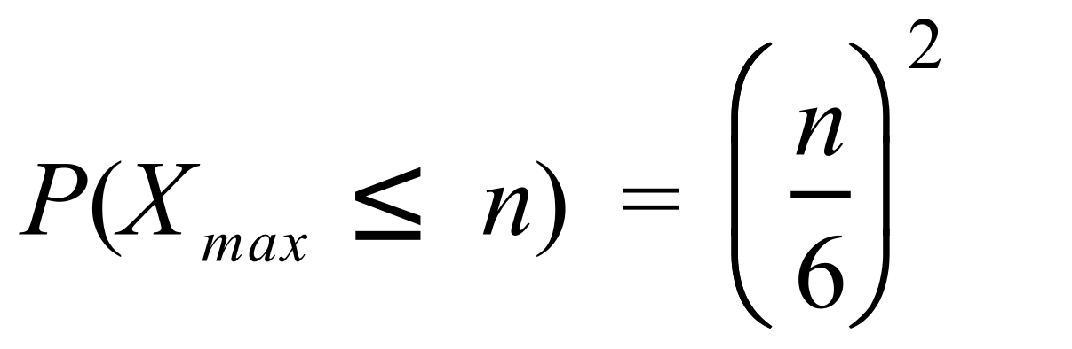 for $n=1,2,3,4,5, \text{or }6$ (2 marks)

- Vanessa is offered the following bet:

She wins $1 if $X_{max} ≤4$ next time she rolls the two dice, but loses $1 if $X_{max}>4.$

How much should Vanessa expect to win/lose if she accepts this bet 100 times?
(2 marks)

- Use the formula in part (a) to complete the following table (2 marks)
$$n$$ | $$P(X_{max}=n)$$
1 | 1/36
2
3
4
5
6

- Calculate $E\left(X_{MAX}\right),$ the expected value of $X_{max}.$ (2 marks)

- Calculate $Var(X_{MAX)},$ the variance of $X_{max}$. (2 marks)

- Estimate 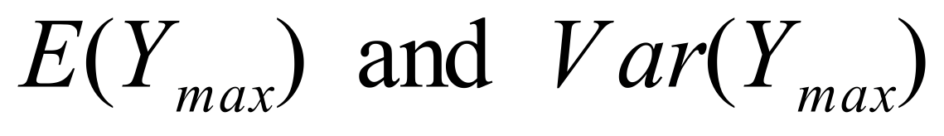 if 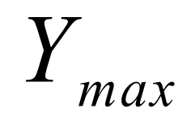 is the maximum value obtained by rolling not two, but a very large number of fair dice. Justify your answer briefly. (3 marks)

Question 13 (5 marks)

There are 65 orange trees at Macintosh Orchard, and each tree yields an average of 420 oranges annually. Macintosh Orchards is ready to expand. They are aware that for each additional tree planted within the orchard, the average number of oranges yielded by each tree decreases by 4; as a result of crowding.

(a) Using calculus techniques determine the optimal number of trees to plant in the orchard. Clearly identify the variables used in your working.
(4 marks)

(b) Calculate the expected percentage increase in the yield for Macintosh Orchard.
(1 mark)

Question 14 (5 marks)

The graph below shows the function . Three rectangles are also drawn.
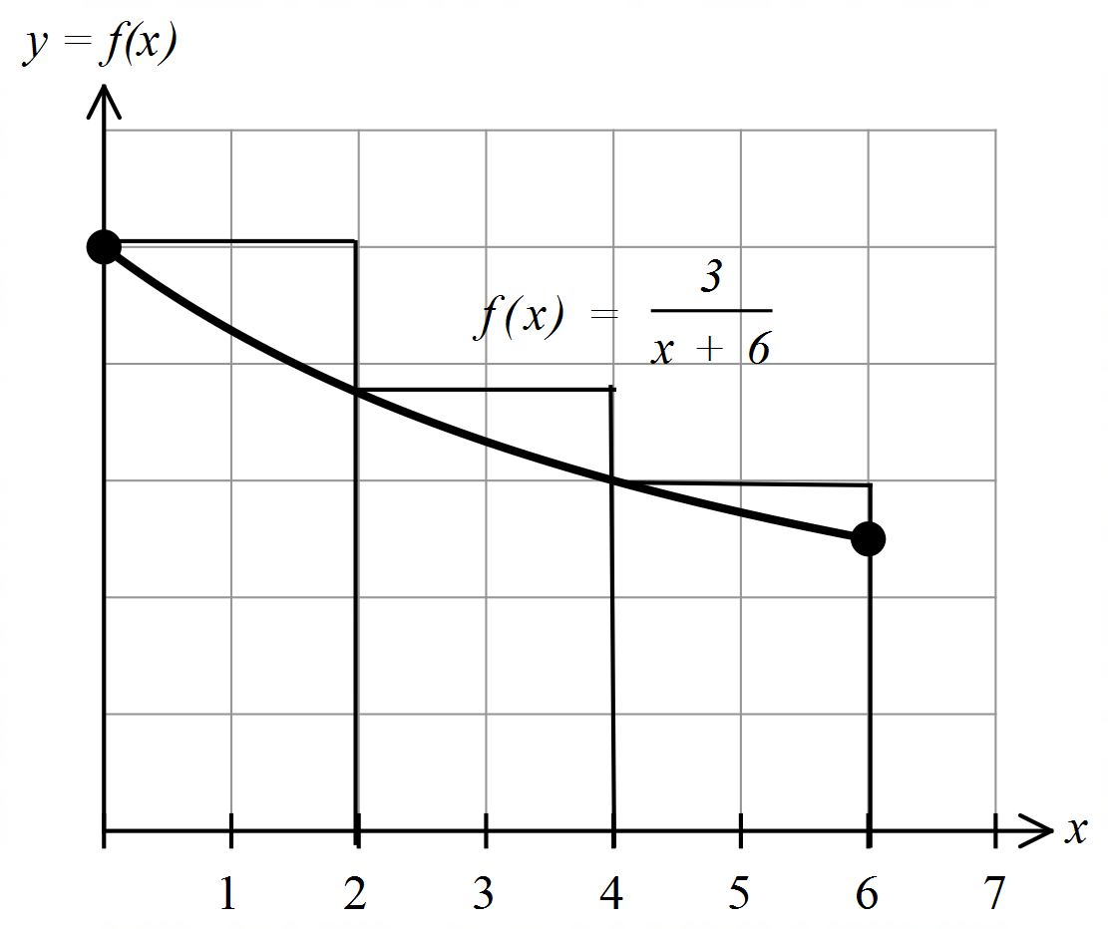

(a) By considering the areas of rectangles, demonstrate and explain why (3 marks)

(b) If 6 rectangles of equal width were used and the same process applied to the diagram
above as in part (a), would the interval obtained be smaller or wider? Explain.
(1 mark)

(c) Determine accurate to 4 significant figures. (1 mark)

Question 15 (6 marks)

Sketch a possible graph of and f (x) on the axes provided using the information from the sketch of shown below.

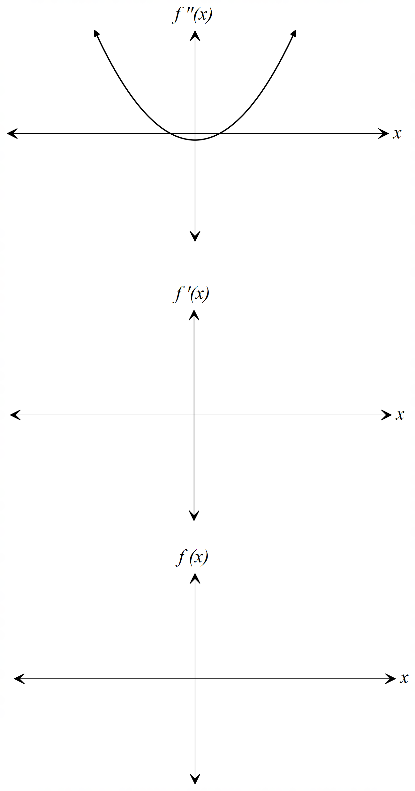

Question 16 (5 marks)

The displacement (s) of a particle moving in rectilinear motion can be modelled by the function where s is measured in metres and time, t, is measured in seconds, .

(a) Determine the rate of change of displacement with respect to time at 5 seconds.
(2 marks)

(b) During which times interval/s is the particle moving towards the origin? (3 marks)

Question 17 (14 marks)

On the top shelf of a cupboard in the pantry there are 5 coffee mugs, 2 of which are chipped. On Monday morning Abigail reaches up and randomly chooses 2 of the mugs.

- Complete the following table showing the probability distribution of $A,$ the number of
unchipped mugs chosen by Abigail. (3 marks)
$$x$$ | $$P(A=x)$$
$$0$$
$$1$$
$$2$$

- Calculate the expected value and the variance of $A.$ (3 marks)

- On Tuesday morning the 5 mugs are back on the shelf. Benjamin randomly chooses one mug and notes whether or not it is chipped. He puts the cup back on the shelf and then for the second time randomly chooses a mug. Let $B$ denote the number of unchipped mugs chosen by Benjamin.

Explain why $B$ has a binomial distribution, but $A$ does not. (3 marks)

- On Wednesday morning the 5 mugs are back on the shelf again. Caitlin randomly chooses mugs from the shelf, one at a time, and puts them on the kitchen table. She stops as soon as she has 2 unchipped mugs.

How many mugs, on average, should Caitlin expect to have to take down from the shelf in order to obtain 2 unchipped mugs. (5 marks)

Question 18 (7 marks)

Consider the graph of 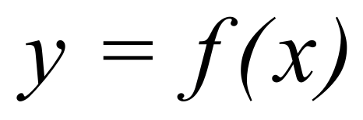 which is drawn below.
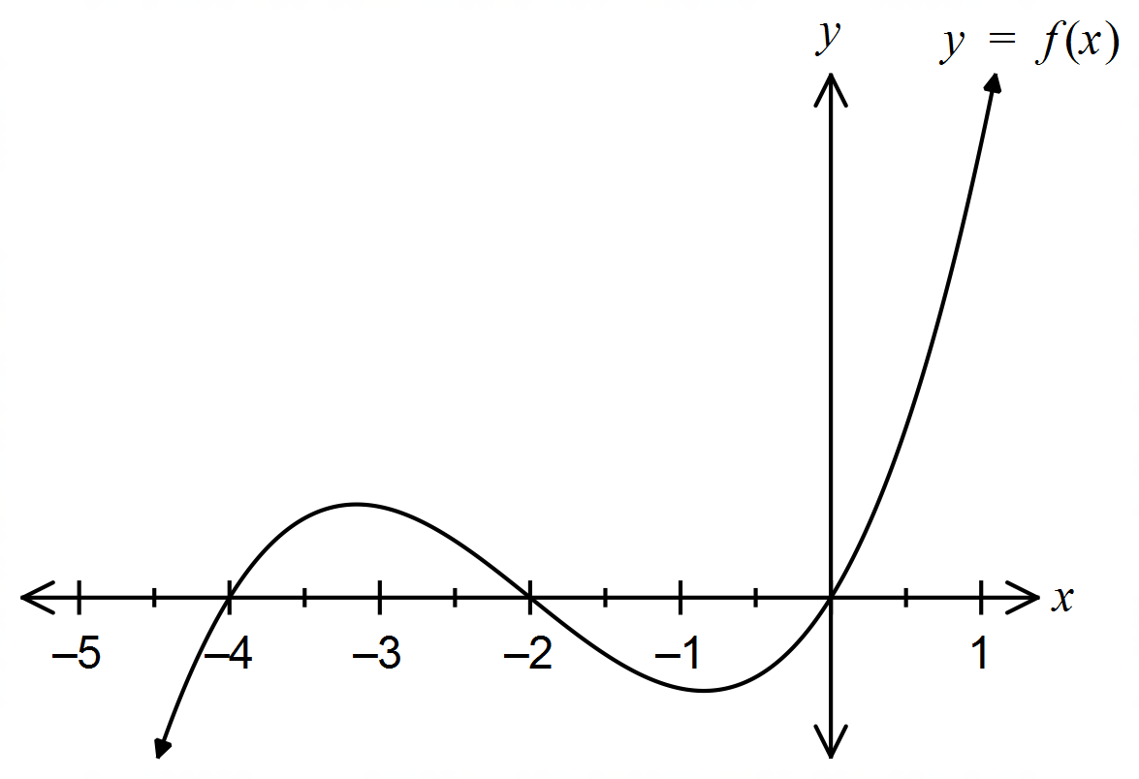

Let 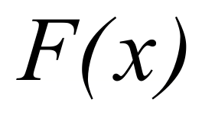 be defined by the integral 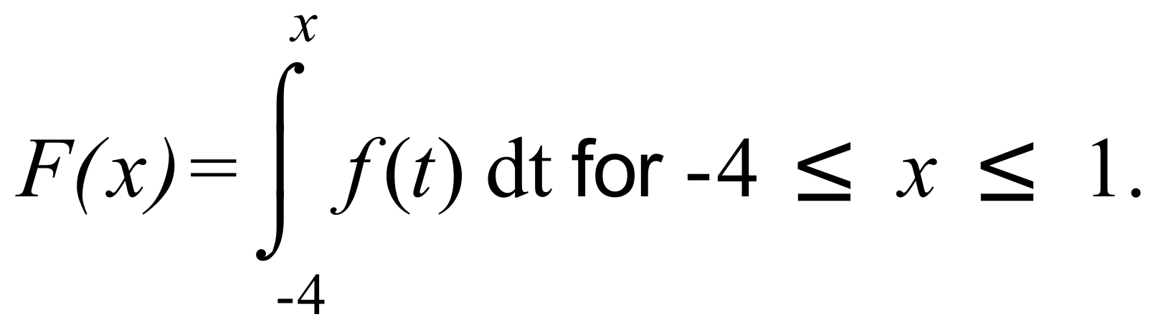
It is known that F has two points of inflection within the interval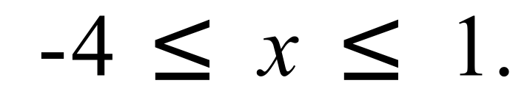

(a) Determine 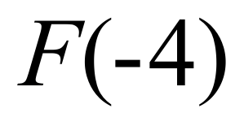. . (1 mark)

(b) For what value/s of x does F have stationary points? (2 marks)

(c) For what value/s of x is F increasing? Justify your answer. (2 marks)

(d) State the approximate values of x for which F has points of inflection within the interval
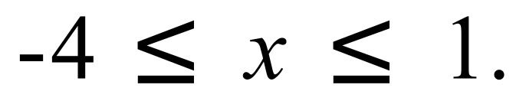 (2 marks)

Question 19 (4 marks)

Determine the exact area of the region bounded by the curves with equations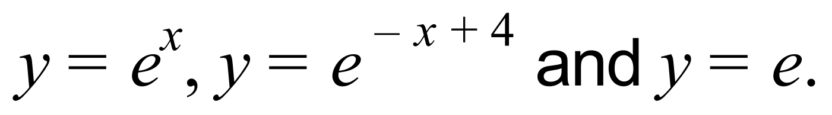

Question 20 (8 marks)

The acceleration (ms⁻²) of a particle moving along a straight line is given by where t is time in seconds. Initially the particle is at rest at its origin, O.

(a) Determine an expression for the velocity of the particle at any time t. (2 marks)

(b) Does the particle change direction? Justify your answer. (2 marks)

(c) Determine the average speed of the particle during its first three seconds of motion.
(2 marks)

(d) With reference to the velocity and acceleration of the particle, describe the motion of the particle at t = 2 seconds. (2 marks)

Question 21 (5 marks)

Three tennis balls of radius cm fit snugly into a closed cylindrical can. A cross section of the metal can with the tennis balls inside is shown in the diagram below.
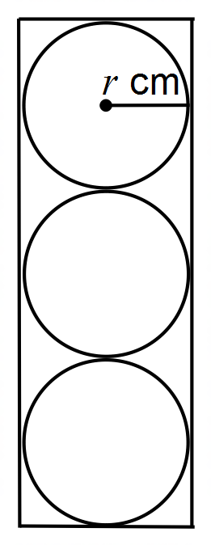

(a) Determine an expression for the surface area of the can in terms of r. (1 mark)

International standards state that the diameter of a tennis ball must be at least 6.541 cm. The maximum allowable diameter (6.858 cm) is roughly 4.8% larger than this.
(b) Use the incremental formula to determine how much more metal is required per can if the radius of the balls is increased 4.8% from the minimum allowable size.
(4 marks)

Question 22 (12 marks)

The monthly averages during 2017 of the daily maximum temperatures at a certain city, calculated to the nearest degree Celsius, are shown below. The horizontal axis gives the months, from January as month 1 through to December as month 12.

- Is the city more likely to be in the northern hemisphere or the southern hemisphere? Justify your answer briefly. (2 marks)

- Use your calculator to estimate the average across the entire year of the daily maximum temperature. (You may ignore the fact that some months have more days than others.) (2 marks)

- Use your calculator to estimate the standard deviation of the monthly averages.
(2 marks)

- Express the average and standard deviations obtained in parts (b) and (c) in Fahrenheit units.

Recall that (2 marks)

- Suppose that the daily maximum temperature throughout the year is modelled by the formula

whereis the maximum daily temperature during month t and where $A$and $B$ are constants.

Use the data to estimate $A$ and $B$ to the nearest integer. (2 marks)

- According to the model in part (f), the daily maximum temperatures are lowest in which month? (2 marks)

Additional working space
Question number: __________________

© MAWA, 2018
This examination is Copyright but may be freely used within the school that purchases this licence.
- The items that are contained in this examination are to be used solely in the school for which they are purchased.
- They are not to be shared in any manner with a school which has not purchased their own licence.
- The items and the solutions/marking keys are to be kept confidentially and not copied or made available to anyone who is not a teacher at the school. Teachers may give feedback to students in the form of showing them how the work is marked but students are not to retain a copy of the paper or the marking guide until the agreed release date stipulated in the purchasing agreement/licence.
Published by The Mathematical Association of WA
12 Cobbler Place, MIRRABOOKA 6061

